

Sample Quantiles
Frequency
0
5
10
15
20
25
0
100
300
500
700
Frequency
1
2
0
10
20
30
40
50

0 5 10 15 20 25 0 1 2 3 4 5

Value Value

hormone1 − Outcome=0 hormone1 − Outcome=1
Sample Quantiles
3
4
5
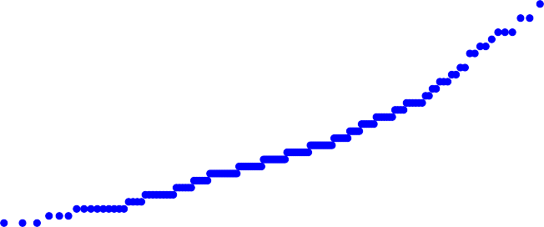

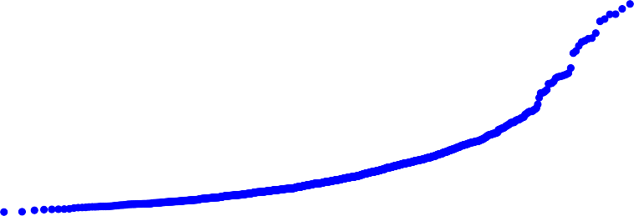
Sample Quantiles
Frequency
0
500
1000
2000
0
100
200
300
400
Frequency
0
500
0
20
40
60
80
100 120

0 500 1000 1500 2000 2500 0 500 1000 1500 2000 2500 3000

Value Value

hormone2 − Outcome=0 hormone2 − Outcome=1
Sample Quantiles
1000 1500 2000
2500
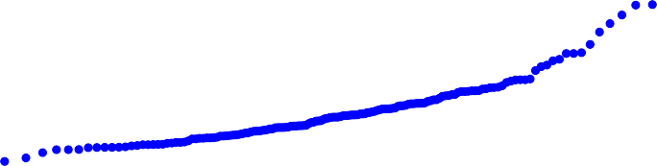

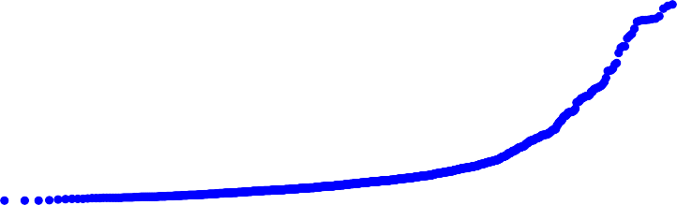
Sample Quantiles
Frequency
0
20
40
60
80
100
120
0
200
400
600
800
Frequency
0
20
40
0
20
40
60
80
100
120

0 20 40 60 80 100 120 0 20 40 60 80 100

Value Value

hormone3 − Outcome=0 hormone3 − Outcome=1
Sample Quantiles
60
80
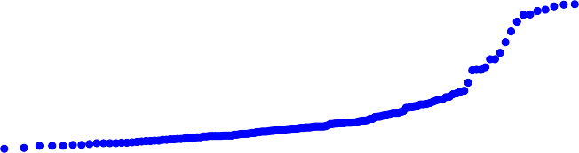



Sample Quantiles
Frequency
0
20
40
60
80
100
120
0
200
400
600
800
Frequency
0
20
40
0
20
40
60
80
100 120

0 20 40 60 80 100 120 140 0 20 40 60 80

Value Value

hormone4 − Outcome=0 hormone4 − Outcome=1
Sample Quantiles
60
80
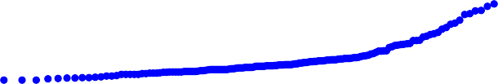

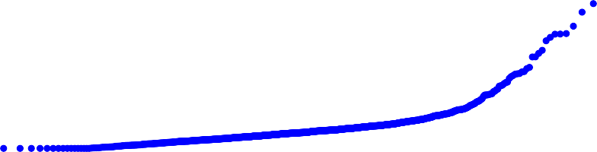
Sample Quantiles
Frequency
0
1000
3000
5000
0
200
400
600
800
Frequency
0
500
1000
0
20
40
60
80

0 1000 2000 3000 4000 5000 6000 0 500 1000 1500 2000

Value Value

hormone5 − Outcome=0 hormone5 − Outcome=1
Sample Quantiles
1500
2000
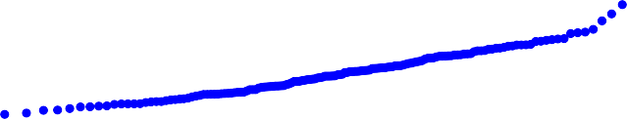

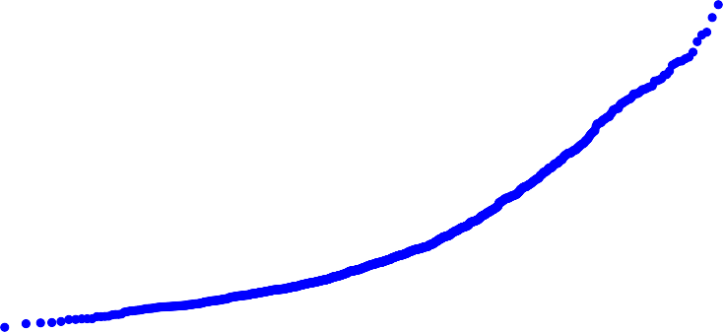
Sample Quantiles
Frequency
0
100
200
300
0
100
200
300
Frequency
0
50
100
10
20
30
40
50
60

0 | 100 | 200 | 300 | 400 | 0 | 50 | 100 | 150 | 200 | 250 | 300
 |  | Value |  |  |  |  |  | Value

hormone6 − Outcome=0 hormone6 − Outcome=1
Sample Quantiles
150
200
250
0
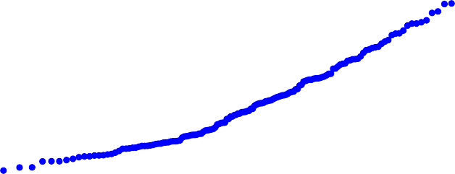

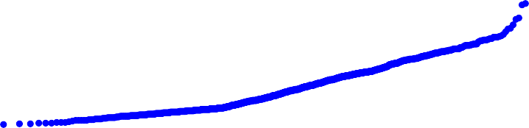
Sample Quantiles
Frequency
0
10
20
30
40
0
100
200
300
400
500
Frequency
0
5
10
15
0
20
40
60
80

0 10 20 30 40 50 0 5 10 15 20 25 30 35

Value Value

hormone7 − Outcome=0 hormone7 − Outcome=1
Sample Quantiles
20
25
30
35
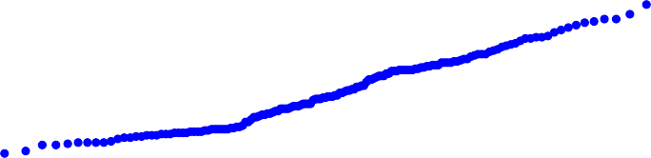

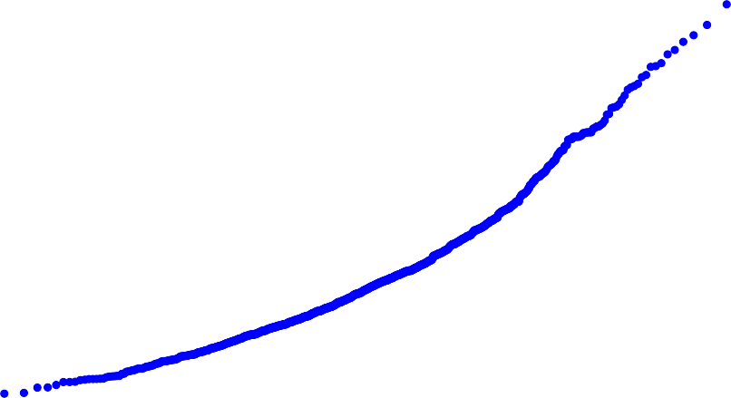
Sample Quantiles
Frequency
0
100
200
300
400
500
0
50
100
150
200
250
Frequency
100
10
20
30
40

0 | 100 | 200 | 300 | 400 | 500 | 600 | 0 | 100 | 200 | 300 | 400
 |  |  | Value |  |  |  |  |  | Value

hormone8 − Outcome=0 hormone8 − Outcome=1
Sample Quantiles
200
300
0
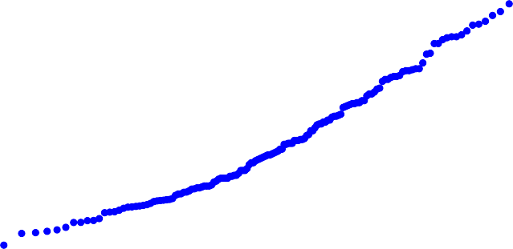

hormone10_generated − OutDcoismter=ib0 ution of hormone10_generatheordmone10_generated − Outcome=1
Sample Quantiles
Frequency
0
50
100
150
200
250
0
200
400
600
800
1000
Frequency
0.0
0.5
1.0
1.5
0
20
40
60
80

0 50 100 150 200 250 0.0 0.5 1.0 1.5 2.0 2.5 3.0

Value Value

hormone10_generated − Outcome=0 hormone10_generated − Outcome=1
Sample Quantiles
2.0
2.5
3.0
